00.00.0000 /EN
FCI-Standard Nr : 000
YAKUTIAN LAIKA
(KOLYMA-INDIGIRKA LAIKA, NORTH-EAST SLED DOG)
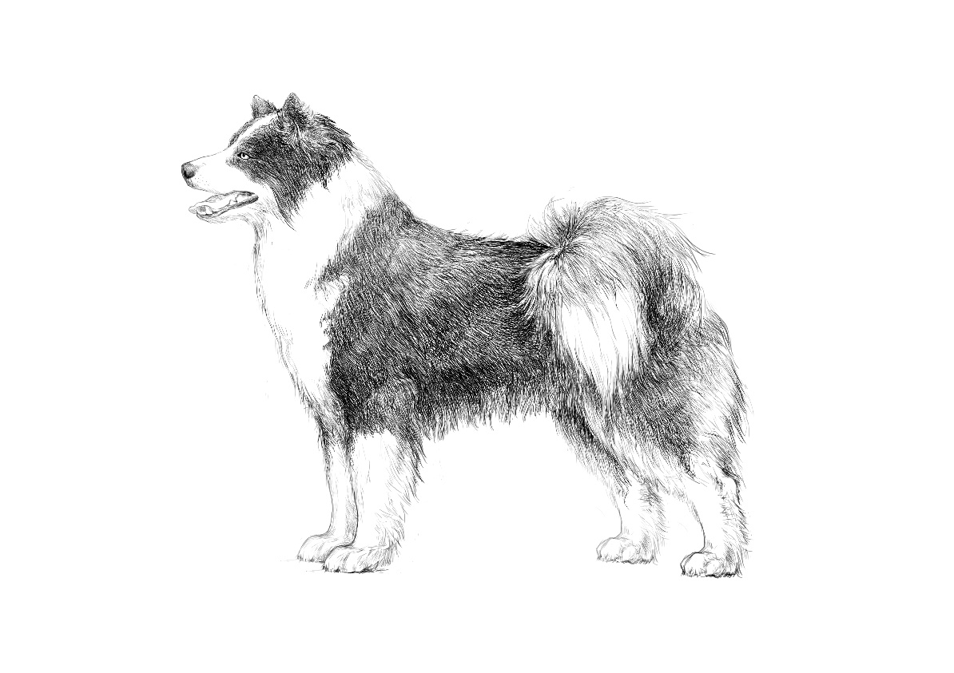
ORIGIN: Russia
DATE OF PUBLICATION OF THE OFFICIAL VALID STANDARD: 00/00/0000
Approved by the Presidium of the Union of Public Cynological Organizations «Russian Kynological Federation» on July 24, 2013
Amendments approved by the Presidium UPCO RKF on September 05, 2018
TRANSLATION: September 05, 2018
UTILIZATION: Sledge and hunting dog.
PROPOSED FCI CLASSIFICATION: Group 5 (Spitz and primitive types)
Section 1 Nordic Sledge Dogs
With working trial
Breed not recognized by FCI

BRIEF HISTORICAL SUMMARY: The Yakutian Laika is an ancient native dog breed which was naturally bred by aboriginal people of the North East of Russia as a sled dog and a hunting dog. Certain archaeological discoveries confirm that the local people used dogs for sledding and hunting as far back as 8000 years ago. The very first references about dogs in this region relate to 1633. The first published account of the Yakutian dogs was titled “The ways of travelling by Yakutians in winter” which was included in the book “Northern and Eastern Tartary” by Nicholas Witsen (Amsterdam, 1692). The first description of the Yakutian Laika appeared in the book "Geography of the Russian Empire" (Derpt, 1843), which announced it to be a "dog of a special breed”. The first mention of the Yakutian Laika’s total number found in the book "Statistical tables of the Russian Empire" (St. Petersburg, 1856): "There are 15157 dogs in the Yakut region used for sled work". The first Breed Standard for the North-East Sled Dog was adopted in 1958 and it formed the basis for the Yakutian Laika Breed Standard published in 2005 by the Russian Kynological Federation. For many centuries, the Yakutian Laika accompanied the northern man in everyday life, helping him to hunt, vigilantly watch his home, herd reindeers and transport goods in the severe conditions of the Far North. These skills have glorified the Yakutian Laika as a versatile breed not only in Russia but also in many countries on different continents.

GENERAL APPEARANCE: Yakutian Laika is a dog of medium-size, strong, compact, well-muscled, with moderately long legs and thick skin with no signs of looseness.
The coat is well developed and should be sufficient for living and working in severe Arctic conditions. Sexual dimorphism is clearly pronounced, males are stronger and more powerful than females.

IMPORTANT PROPORTIONS:
- The length of body from shoulder to croup exceeds the height at withers by 10-15%.
- The length of the head is a bit less than 40% of the height at withers.
- The length of the muzzle is 38-40% of the length of the head.
- The length of the fore leg to the elbow is 52-54% of the height at withers.

BEHAVIOUR/TEMPERAMENT: Yakutian Laika is bold, agile, contact, friendly, sociable and energetic dog.

HEAD: Wedge-shaped, moderately pointed, proportional to dog’s size.
CRANIAL REGION:
Skull: Moderately broad, slightly rounded, with a high forehead.
Cheeks: Moderately pronounced.
Stop: Well pronounced.
FACIAL REGION:
Nose: Of big size, with wide nostrils, black or brown in colour.
Muzzle: Well filled under the eyes, wedge-shaped, gradually tapering towards the tip of the nose.
Lips: Dry, tight-fitting, well pigmented.
Jaws/Teeth: Teeth are of big size, white, preferably in a complete set (42 teeth according to the dental formula). Scissors bite or level bite. A tight undershot is acceptable for dogs older than 3 years.

EYES: Set straight and wide, but not deep; almond-shaped. Eyes colour is dark brown, or blue as well as odd eyes (one brown, one blue) or blue segments on brown iris. Dry, tight fitting eye rims matching the colour of nose. Depigmentated eye rim against white background permissible.

EARS: Of triangular shape, set high, wide at the base, thick, erect or tipped. Ears covered with thick, short hair. Ears laid back while moving.

NECK: Of moderate set and length, muscular.

BODY: Compact.
Top line: Straight and firm, with a very slight slope from moderately pronounced withers to the base of the tail.
Back: Firm, wide, straight, muscular.
Loin: Short, wide, muscular.
Croup: Wide, muscular, long, rounded, almost horizontal.
Chest: Broad, rounded in cross-section, with well sprung ribs, long enough, moderately deep.
Underline: Belly reasonably tucked up.

TAIL: Set high, covered with a thick furry coat, curled up as semi-circle on the dog’s back, sickle curve tail allowed. At rest or in long distance movement tail may hang loosely.

LIMBS: Strong, muscular, straight, parallel.

FOREQUARTERS:
General appearance: Straight, parallel, strong, very well muscled.
Shoulder: Sloping, of moderate length.
Upper arm: Muscular, sloping, of moderate length.
Elbow: Tightly fit to chest, placed back.
Forearm: Rather long, parallel.
Metacarpus (Pastern): Short, strong, slightly sloped.

HINDQUARTERS:
General appearance: Strong-boned and well muscled. At rear view – straight and parallel.
Thigh: Broad and muscular.
Stifle (Knee): Well defined.
Lower thigh: Of medium length, strong. Hock joints angulation is well defined.
Metatarsus (Rear pastern): Strong, vertical.
Feet (front and rear): Well arched, tight, with very hard pads and thick coat (brush) between toes. Hind feet are slightly bigger than the front feet.

GAIT / MOVEMENT: Fast, elastic. Characteristic gaits are brisk trot and gallop.

COAT:
Hair: Thick, glossy, straight, coarse, of medium length, with very well developed thick and dense undercoat. On the neck it forms mane, especially clearly pronounced in males; thick feathers on the back sides of the front and hind legs; the tail feathered with a small fringe. Coat is shorter on the head and front sides of the legs.
Colour: White and any mixed (double- or triple - coloured).

SIZE AND WEIGHT:
Height at the withers: Males: preferable height is 55-59 cm.
Females: preferable height is 53-57 cm.

FAULTS: Any departure from the foregoing points should be considered a fault and the seriousness with which the fault should be regarded should be in exact proportion to its degree and its effect upon the health and welfare of the dog and its ability to perform its traditional work.

SEVERE FAULTS
- A strong deviation from the physique, short legs;
- Square format;
- Flat, shallow, or barrel chest;
- Poorly balanced, sluggish movements;
- Wavy, soft, too short hair with a poorly developed undercoat.

DISQUALIFYING FAULTS
- Aggressive or overly shy dogs;
  - Any dog clearly showing physical or behavioural abnormalities;
  - Disproportions in conformation;
  - Males in feminine type;
  - Overshot, undershot with a gap, misaligned jaws;
  - Total depigmentation of nose, eye rims and lips;
  - Any monochrome colour other than white;
  - Short (smooth) hair;
  - Any behavioural or constitutional deviations affecting the health of the dog and its ability to perform the work traditional for this particular breed.

N.B.:
- Male animals should have two apparently normal testicles fully descended into the scrotum.
  - Only functionally and clinically healthy dogs, with breed typical conformation, should be used for breeding.

